**PYTHON LAB REPORT**

**ON**

**“Secured Password Generator”**

**BACHELOR OF ENGINEERING**

**In**

**Computer Science**

**SUBMITTED BY**

**Group - 4**

**SUBMITTED TO**

**C.S.E Department**

**Model Institute of Engineering and Technology (Autonomous)**

**Jammu, India**

**2022**

**ABSTRACT**

A secured password generator is software program or hardware device that takes input from a random or pseudo-random number generator and automatically generates a password. Random passwords can be generated manually, using simple sources of randomness such as dice or coins, or they can be generated using a computer.

Speaking regarding the system, the user can create a random password according to various sizes. It additionally presents with an aesthetic color-coded system which indicates the stamina of the password, beginning from very weak to superb password strength. After creating a random password, the system presents it in the clipboard where the user can copy and paste easily.

This GUI based Password Generator supplies the most basic method for generating a solid password for the individuals. In short, this job just concentrates on producing arbitrary passwords.

**INDEX**

|  |  |  |
| --- | --- | --- |
| **Sr. No.** | **TITLE** | **PAGE NO** |
| **1** | **CHAPTER 1-Introduction** | 4 |
| **2** | **CHAPTER 2- Project Overview** | 5 |
| **3** | **CHAPTER-3 Workflow** | 6 |
| **4** | **CHAPTER-3 Screenshots** | 7-8 |
| **5** | **CHAPTER-4 Conclusion** | 9 |
| **6** | **References** | 10 |

**CHAPTER 1- INTRODUCTION**

With growing technology, everything has relied on data and securing these data is the main concern. Passwords are meant to keep the data safe that we upload on the Internet. An easy password can be hacked easily and all the personal information can be misused. In order to prevent such things and keep the data safe, it is quite necessary to keep our passwords very strong.

A password generator is a software application device that creates arbitrary or tailored passwords for individuals. It assists individuals to produce more powerful passwords that offer greater protection for a provided sort of access. These programs produce complex/strong passwords with mixes of numbers, uppercase and also lowercase letters, and also unique personalities such as dental braces, asterisks, slashes, and so on.

**CHAPTER 2- Project Overview**

In our Secured Password Generator, the user can create a random password according to various sizes (8/12/16). After creating a random password, the system presents it in the clipboard where the user can copy and paste easily.

This GUI based Password Generator supplies the most basic method for generating a solid password for the individuals. In order to run the task, you must have set up Python, on your PC.

**CHAPTER 3: - WORKFLOW**

START

ENTER LENGTH

Using Checkbox

n == 8

||

n == 12

||

n ==16

TRUE

GENERATE PASSWORD

OF Length = n

FALSE

PASSWORD LENGTH = 0

PRINT

END

**CHAPTER 4:- SCREENSHOTS**

This is the Basic User Interface of our project.

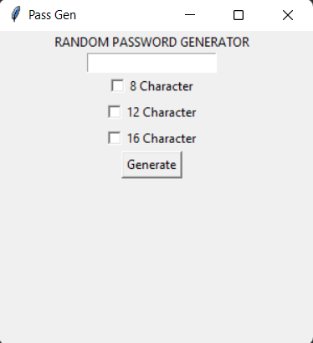

This is the user interface of our project in which all the undergoing procedures at each step are shown at different elements.

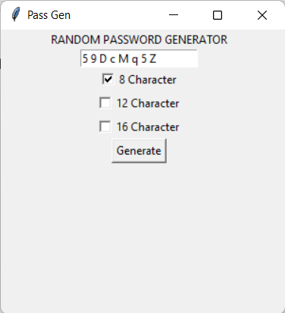 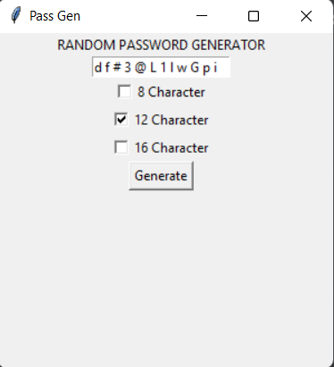

We can compare its elements and functioning with the workflow demonstrated earlier in this report to understand what’s happening at each step.

**Generated Password:**

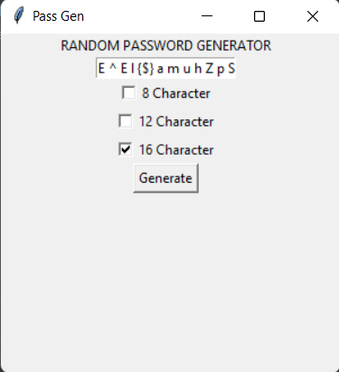

**CHAPTER 5: - CONCLUSION**

We completed with our GUI Project using Python Tkinter. We have successfully created a secured password generator project using python. We used popular tkinter library to rendering graphics in our display window. We learned how to create buttons, input textfield, labels, and spinbox. In this way, we successfully created our password generator python project.

**References:**

* [**https://www.python.org/**](https://www.python.org/)
* [**https://github.com/**](https://github.com/)
* [**https://www.wikipedia.org/**](https://www.wikipedia.org/)
* [**https://www.geeksforgeeks.org/**](https://www.geeksforgeeks.org/)